Computer Language Coding Concepts

Special Access
< Article text >

< Section title >
< Section text >

See also: < List of articles >

Author & Copyright: <Jan-Joost van Zon> Date: <May 21, 2008> – <May 22, 2008> Location: <Oosterhout, The Netherlands> Status: [ Under Construction | Finished | … ]

From the original Symbol documentation

Access Ways
< Do neighbor access and child access protect the independence of types? As a substitute for the old, false rule: ‘Can’t call upward in the ancestry’? >

There’s several ways to access a procedure. The most common way is for procedure’s of the same object to call upon eachother. The second most common way is for a parent to access a child’s procedures. A global object is accessible from anywhere within the globality and there are more ways. I will discuss these different ways of access one by one in this section.

Neighbor Access
<Discuss procedures within the same object accessing eachother>

Child Access
The normal way of accessing an object is child access: an object can only access its what’s inside of it: its ancestors.

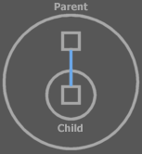
<Shit. This is bullshit, I need to make a call from a procedure. The line above is a reference line.>

An access always takes place in a procedure call. In this picture Parent is accessing Child.

You can’t all anything higher in the encapsulation hierarchy, so an object can’t access anything outside the object. If it is to access anything outside the object, it needs to contain a reference to something outside the object.i

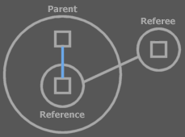

The object is then accessing this reference, which is inside the object. The reference just happens to resolve in something outside the object, but the parent is still accessing something inside itself.

Global Access
< Nice sentence:
Globality makes all direct children accessible to all ancestors
>
There’s also a way to make objects accessible not only to parents, but accessible from anywhere. This makes the accessed objects global.

A special symbol is used: a pentagon.

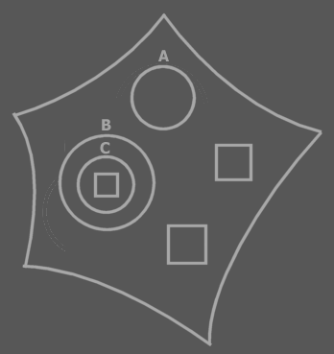

Anything directly inside the pentagon is accessible from anywhere. So the (public) direct children of the pentagon are global:

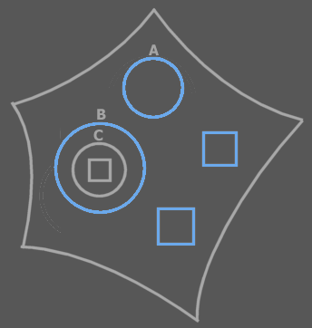
The blue symbols are accessible from anywhere inside the pentagon.

A pentagon and all its contents are also called a globality.

It’s like any object inside a globality has a reference to the globality object:

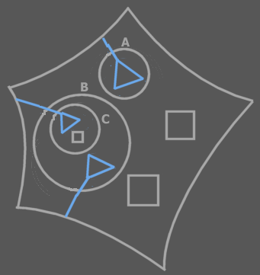

These references don’t really exist, though. Everything global is just reachable inside every object inside a globality.

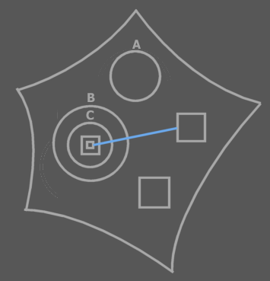

In this the solid line can be a call, because it’s a reference to something global.

A globality can also be viewed as being a module, or software component. It is a way to order code into components. Globalities can be embedded just like as objects:

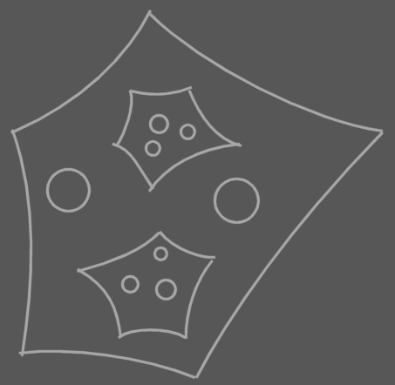

In fact, a globality symbol is an object symbol too. It works as a triangle: you can access things in the globality directly, but also by qualifying it with the globality identifier, but it has the special side effect that anything it directly contains can be directly accessed from anywhere.

When you want one globality to use another, you make a reference to the other globality:

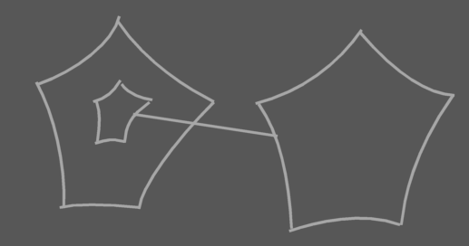

The child globality can then be accessed like a circle or a triangle, but refers to an existing instance of the globality (software component). Since the globality is a direct child of another globality, anything in the contained globality is just as global as anything in the parent globality. However, if you make the child globality private, it’s not accessible outside the parent globality. It is accessible as global inside the parent globality, though.

In other languages, globalities usually contain a large amount of code, because it’s not easy to handle many globalities. In symbol it’s easier to manage globalities and whenever you need the effect of having a small, local, globality (or software component), you can easily use a globality.

This is also an invitation to making a more refined division in software components. You can not only easily work with a division in more components. You can also embed software components. And you can refinedly control referencing existing instances of software components.

The child globality in the picture above can only access things global inside itself. It can not access the global things of its parent globality.

Pentagons not Exchangable with Triangles and Circles
A pentagon is not exchangable with triangles and circles as much as triangles and circles are exchangable. Global has the side effect that things become accessible where otherwise inaccessible. If you suddenly replace the pentagon with a circle or triangle it would mean that things formerly global are no longer global and all sorts of accesses in the globality object are suddenly invalid. For that a pentagon stays a pentagon and a reference to it can only be a pentagon itself.

Extra Indication
There are two common ways to extra denote that you’re referencing something global.

Put a multiply peeled pentagon around the call:

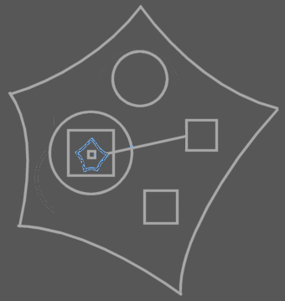
This pentagon reference doesn’t really exist, though.

You can also put a multiply peeled pentagon in the direct parent object and reference this multiply peeled pentagon, rather than the global symbol directly:

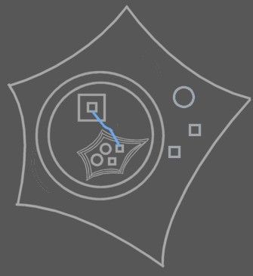

This multiply peeled pentagon doesn’t exist either.

Interface Access
The separate interfaces of an object:

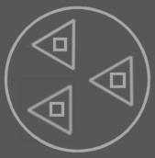

can be accessed through a reference to the triangle, just like you would access a circle:

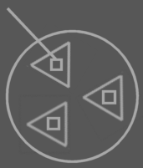

The special thing about a triangle, though is that its members are also directly accessible through its parent. When referencing the circle, you can access the triangle’s members as if the triangle capsules weren’t even there.

You can’t see in the picture above if the called square is referenced through the circle or through the triangle. If you want to indicate that it’s accessed through the circle, you can put an access symbol with the circle. If you want to indicate that it’s accessed through the triangle, you put an access symbol with the triangle, or with both the circle and the triangle.

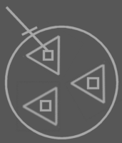  Accessed through the Circle:  Circle . Procedure | 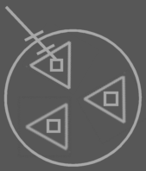  Accessed through  the Circle and the Triangle:  Circle . Triangle . Procedure | 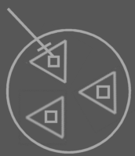  Also accessed through  the Circle and the Triangle:  Circle . Triangle . Procedure

In text code you can see the difference all the more. I’ve put the text code under the diagrams above.

So its like the borders of triangles can be ignored in inward access. You don’t have to access the triangle in order to access its members.

< This concept could have a place in Genericity. >

Clause Access
< Nice sentence:
A procedure makes all direct children accessible to all blocks.
Only is that true?
>
Clauses are embedded procedures. In a diagram these are squares contained in other squares that have no lines. Beware that a diagram may not be showing the line, even when it exist.



Clauses have access to the contents of all their descendant clauses and the procedure definition they’re in. This means that a clause can directly access its containing definition’s members:

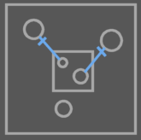

and all its encapsulating clauses:

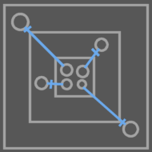

But a clause does not have access to a clause that doesn’t encapsulate it.

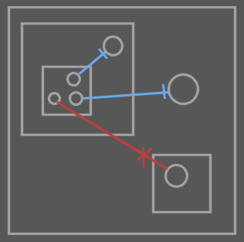

So its like the borders of clauses can be ignored in outward access.

Globalities, Interfaces and Clauses
So usually only parents can access their ancestor’s things.

Globalities, interface implentations and clauses make exceptions on those rules.

The public ancestors of a globality are accessible from anywhere within the globality, the borders of triangles can be ignored and a clause can directly access anything in its descendant clauses and its procedure definition.

Brainstorm

→Access Ways
Clause members can access the members of its ancestor procedure symbols.

]

Other
Globality and triangle are alike. They change the way you can access their members.

A parent block is sorta like a globality in that way.

Child Access
is the normal type of access

